**“Car Rental Service”**

**A Mini Project Report**

**Of Computer Applications**

***Submitted By:***

Ankit Kumar Rai(2115000158)

Praveen Singh(2115000761)

Saurabh Raj Singh(2115000928)

***in partial fulfillment for the award of the degree of***

**Bachelor of Engineering**

**IN**

##### Computer Engineering and Application

**GLA UNIVERSITY,MATHURA**

**November-2023**

#### BONAFIDE CERTIFICATE

Certified that this project report **“Car Rental Service”** is the bonafide work of “**Ankit Kumar Rai”** who carried out the project work under my/our supervision.

|  |  |
| --- | --- |
|  |  |
| **SIGNATURE**  **HEAD OF THE DEPARTMENT** | **SIGNATURE**  **SUPERVISOR** |

Submitted for the project viva-voce examination held on

**INTERNAL EXTERNAL**

**EXAMINER EXAMINER**

#### BONAFIDE CERTIFICATE

Certified that this project report **“Car Rental Service”** is the bonafide work of “**Praveen Singh”** who carried out the project work under my/our supervision.

|  |  |
| --- | --- |
|  |  |
| **SIGNATURE**  **HEAD OF THE DEPARTMENT** | **SIGNATURE**  **SUPERVISOR** |

Submitted for the project viva-voce examination held on

**INTERNAL EXTERNAL EXAMINER EXAMINER**

#### BONAFIDE CERTIFICATE

Certified that this project report **“Car Rental Service”** is the bonafide work of “**Saurabh Raj Singh”** who carried out the project work under my/our supervision.

|  |  |
| --- | --- |
|  |  |
| **SIGNATURE**  **HEAD OF THE DEPARTMENT** | **SIGNATURE**  **SUPERVISOR** |

Submitted for the project viva-voce examination held on

**INTERNAL EXTERNAL EXAMINER EXAMINER**

**ACKNOWLEDGEMENT**

The whole process of developing the project has been quite an experience; a lot of new and interesting things helped us in making this Project a success.

We are highly indebted to **Ms. Robin Khurana** for all the help they provided us throughout the project completion. He was closely involved during all stages of development, right from its inception implementation.

We wish to express our heartiest and venerable regards to our **H.O.D.Mr. Rohit Agarwal** .We are highly indebted to respected madam for all the support that he has always provided for getting all the information for project.

We are also expressing our gratitude to all the professor of GLA University for providing us valuable support and inspiration all through our Btech C.S.E course. We are also thankful to the library staff of our Institute for their help and for providing books and information to us regarding this project.

We express our profound gratitude to all friends who have made innumerable contribution affection and support for the completion of this project successfully and effectively.

**CHAPTER-1**

**INTRODUCTION**

**1.1 Project Over View:-**

In the fast-paced world of today, where convenience and flexibility are paramount, the dynamics of transportation are undergoing a profound transformation. One such transformative element is the evolution of car rental services, reshaping the way individuals and businesses approach mobility.Car rental services have emerged as a pivotal player in the modern transportation ecosystem. The concept has transitioned from a mere alternative to vehicle ownership to a dynamic industry offering diverse solutions for short-term mobility needs.

**1.2 Technology Over View :-**

* HTML,CSS.
* GitHub Link:( https://github.com/Ankitrai27/Cars.git)

**About HTML and CSS importance:-**

**HTML:** Hypertext Markup Language, is a markup language for the web that defines the structure of web pages.It is one of the most basic building blocks of every website, so it's crucial to learn if you want to have a career in web development.

**CSS:** Cascading Style Sheets. It is a style sheet language which is used to describe the look and formatting of a document written in markup language. It provides an additional feature to HTML. It is generally used with HTML to change the style of web pages and user interfaces. It can also be used with any kind of XML documents including plain XML, SVG and XUL.

CSS is used along with HTML and JavaScript in most websites to create user interfaces for web applications and user interfaces for many mobile applications.

**1.3 Organization Over View:-**

Today is the era of information technology and everything is going to be computerized. Almost all institute, company and organization are using computer in their day to day activities. They combine their computers and form network so that they can share their resource and data. Many software companies are working to develop SOFTWARE APPLICATIONS for different organizations in almost every domain. For developing any software from scratch much of the effort, time and money are required.

To make standalone USER APPLICATION, you will probably need the following expertise:

1. A computer interface designer
2. A database programmer
3. Experienced, knowledgeable script writer.
4. And Knowledge of Technology.

Now the main issue involved here is how the efforts of these expertise’s can be saved. All organization needs their system to be automated these days therefore they give their projects to the software companies. We are going to develop an application/website for providing cars on rent at reasonable prices which provides car at very reasonable prices to normal peoples. In an era defined by constant movement and dynamic lifestyles, the demand for flexible and convenient transportation solutions has never been more pronounced. Car rental services have emerged as a beacon of adaptability, offering individuals and businesses the freedom to navigate their journeys at their own pace.

**1.3.1 Software Process Model:-**

The designer's goal is to produce a model or representation of an entity that will later be built. Software design sits at the technical kernel of software engineering and is applied regardless of the software process model that is used. Beginning once software requirements have been analyzed and specified, software design is the first of three technical activities—design, code generation, and test—that are required to build and verify the software. Each activity transforms information in a manner that ultimately results in validated computer software.

In order to evaluate the quality of a design representation, we must establish technical criteria for good design. Later in this chapter, we discuss design quality criteria in some detail. For the time being, we present the following guidelines:

1. A design should exhibit an architectural structure that

(1) Has been created using recognizable design patterns.

(2) Is composed of components that exhibit good design characteristics.

(3) Can be implemented in an evolutionary fashion, thereby facilitating Implementation and testing .

**2.** A design should be modular; that is, the software should be logically Partitioned into elements that perform specific functions and sub functions .

**3.** A design should contain distinct representations of data, architecture, Interfaces and components (modules).

**4.** A design should lead to data structures that are appropriate for the objects to be implemented and are drawn from recognizable data patterns.

**5.** A design should lead to components that exhibit independent functional

characteristics.

**6.** A design should lead to interfaces that reduce the complexity of connections

between modules and with the external environment.

**7.** A design should be derived using a repeatable method that is driven by

information obtained during software requirements analysis.

**CHAPTER-2**

System Analysis

**2.1 Preliminary Investigation:-**

In this section we had done a deep analysis of the proposed system in which we studied about the feasibility of our “Car Rental Services” which was further divided into three categories which are economical, technical and behavioral. We also did the requirement analysis and the specifications were noted and worked upon to find an optimal solution. In our report a proper Entity-relationship diagram and class diagram has been shown to understand the working ability of the system.

**2.1.1 Identification Of Need :-**

Car rental services fulfill a crucial need in today's dynamic and mobile society. As urbanization increases and lifestyles become more fast-paced, the demand for flexible and convenient transportation options has never been higher. Car rental services address this need by providing individuals and businesses with the ability to access a vehicle on a temporary basis. Whether for business trips, vacations, special occasions, or simply as a convenient alternative to owning a car, rental services offer unparalleled flexibility. The cost-effectiveness of renting compared to ownership, coupled with the convenience of selecting a vehicle tailored to specific requirements, makes car rental an attractive choice. Moreover, in emergencies, breakdowns, or unforeseen circumstances, rental services provide a quick and practical solution. Additionally, the industry's responsiveness to environmental concerns, with the availability of eco-friendly vehicle options.

The application/website that we have developed is user friendly and easy to operate because there are lots of easily available options which will provide you all the optons as per person’s need. Even a new user or novice can get use to after once he had used our application.

**2.1.2 Feasibility study:-**

**Economical Feasibility:-**

The project is economically feasible as there is no special investment that has to be done for hardware and software. This project requires just a computer with minimum requirement. No investment in maintaining the database is required

Economic feasibility is the most frequently used method for evaluating the effectiveness of a candidate system. More commonly known as cost/ benefit analysis, the procedure is to determine the benefit and saving that are expected from a candidate system and compare them with the costs.

This project “Car Rental Services” is economic feasible according this specification. Because it has

1) Low maintenance cost.

2) Low development cost.

**Behavioral Feasibility:-**

This feasibility tells how much the project and user of the project are adaptable to change. Since, this project will be requiring only the knowledge of the internet,trip-details,date,locations which will used to open our website and this website provides very user friendly interface so that is easily adoptable.

Our project will behave in very simple manner because most of the users who will access it will be not be so user friendly and they will need a simple working of the system so that they could understand it easily and use it properly. This make sour project Behavioral feasible.

**Time Feasibility:-**

Our project has a length enough that can be completed in a given period of

Time. So our project fulfills the Time Feasibility Constraint.

**Resource Feasibility:-**

As such we do not have any special hardware and software resource

Requirement and the human resource is competent enough to complete the

Project in a specific time .Thus the Resource Feasibility is also fulfilled.

**2.2 Requirment Analysis :-**

Effective requirement analysis is the cornerstone of developing successful and

user-friendly car rental services. Understanding the needs and

expectations of both customers and stakeholders is essential for creating a

system that not only meets but exceeds expectations. Here's a breakdown of the

key components of requirement analysis for car rental services:

**2.2 .1 User Requirements:-**

**User Profiles:** Identify the diverse user groups, such as individual renters, business clients, and tourists, each with unique needs and preferences.

**Use Cases:** Define the typical scenarios in which users will interact with the system, including reservations, vehicle pickup, return, and payment processes.

**User Experience (UX):** Prioritize a seamless and intuitive user interface to enhance the overall user experience, ensuring ease of navigation and clear communication.

**2.2.2 Functional Requirements:-**

**Reservation System:** Specify the features of an efficient reservation system, including real-time availability, multiple vehicle options, and flexible booking periods.

**Payment Integration:** Include secure and efficient payment processing, supporting various payment methods and providing transparent pricing structures.

**2.2.3 Data Flow Diagram:-**

**Car Rental**

**Services**

**User**

**Registration.**

**Vehicle**

**Reservation.**

**Rental**

**Transaction.**

**CHAPTER-3**

Software Design

**3.3.2 Table Structure:-**

|  |  |  |  |  |
| --- | --- | --- | --- | --- |
| **S. No.** | **Task Name** | **Start** | **Finish** | **Week’s**  **(Approx.)** |
| **1** | **Analysis&Planning** | **02/11/23** | **9/02/23** | **1** |
| **2** | **Designing** | **14/11/23** | **22/11/23** | **2** |
| **3** | **Coding** | **15/11/23** | **22/11/23** | **2** |
| **4** | **Testing** | **22/11/23** | **24/11/23** | **1** |
| **5** | **Implementation** | **25/11/23** | **25/11/23** | **1** |
| **6** | **Documentation** | **26/11/23** | **27/11/23** | **1** |
| **7** | **Total** | **-** | **-** | **8** |

**3.5.1 Screen Layout:-**

**Home Page:**

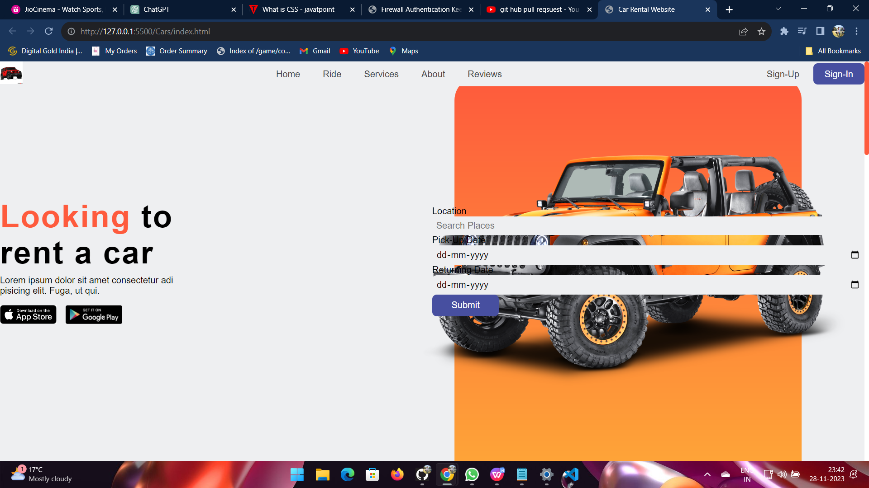

**Services Provided:**

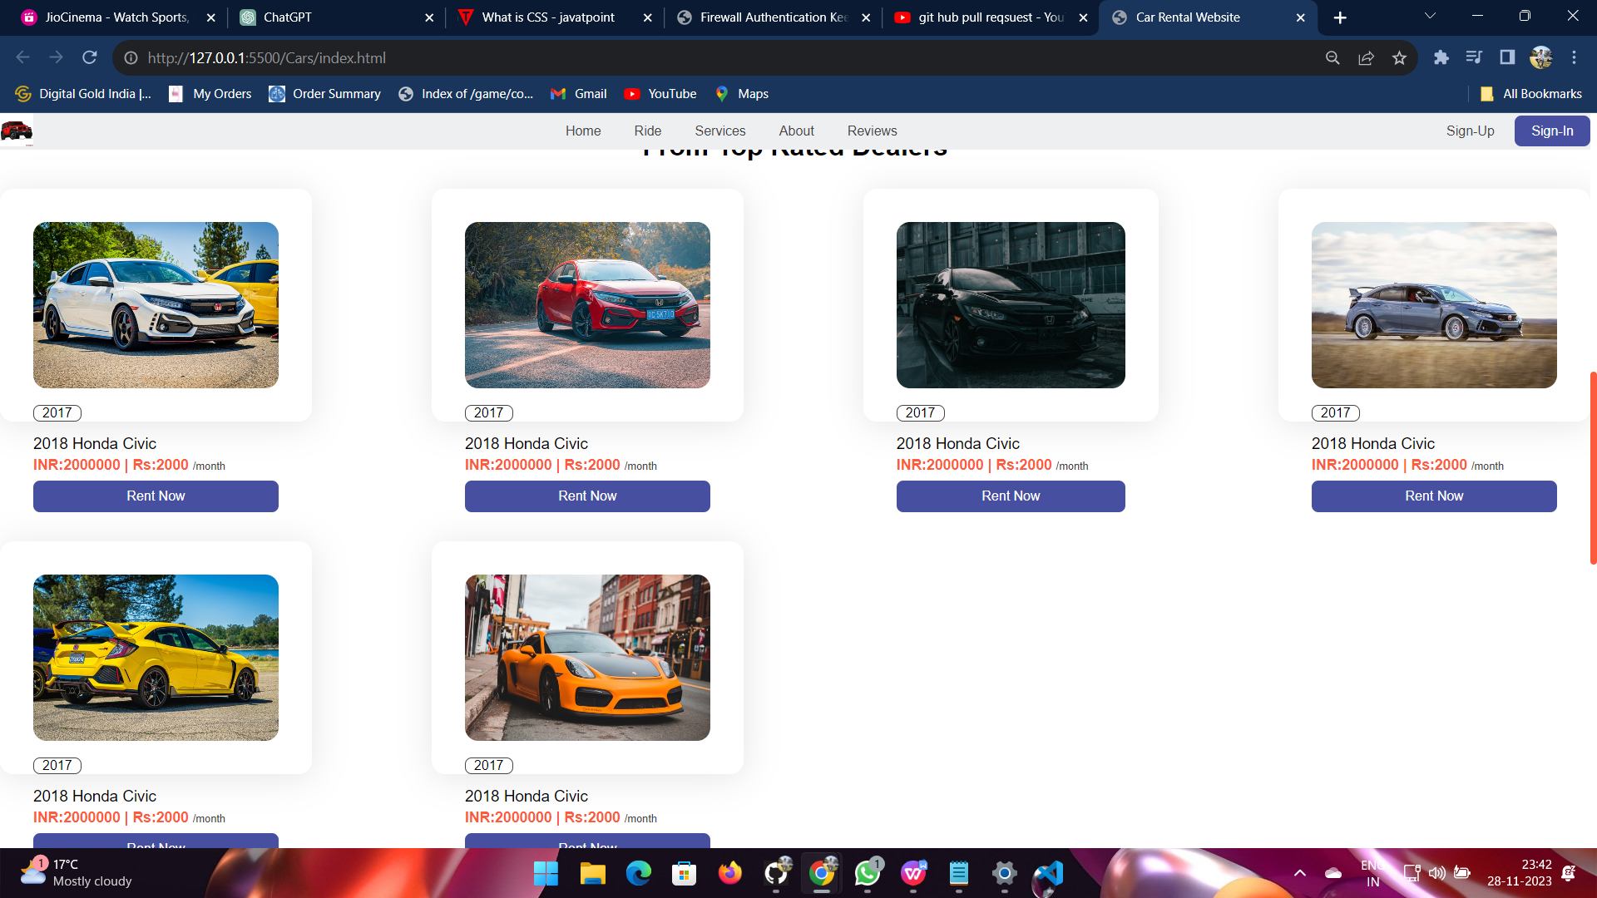

**Reviews Section:**

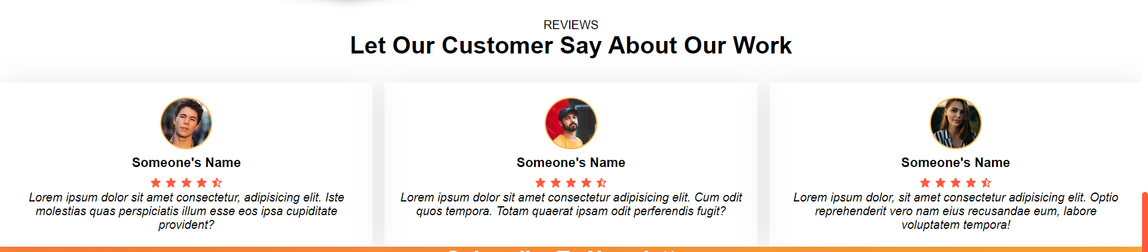

**Payment by Cash Window:**



**CHAPTER-4**

Testing

**Testing:-**

Testing is a critical element of software quality assurance and represents the ultimate reviews of specification, design and coding. Testing is concerned with uncovering of the system error. Testing involves the process of checking the system thoroughly and making shore that no unwanted result it shows. So that user can access it properly and with any error.

**4.1 Objective of Testing are:-**

* Testing is done with intent of finding an error.
* A good test case is one that has high probability of finding an uncovered error.
* Testing is done in order to check the various control flow of system.
* Testing makes the system to work all its features properly without showing any unexpected result.

**Testing Data Set:-**

All the data sets are tested thoroughly and this helps in getting rid of all the errors and exception will be generated due to the lack of the data requested by the user in the database.

Our project i.e. Car Rental Service needs no special type of testing for the data set. Because in our project the user will get all the information from the database in a predefined format set by the system developer. No other special information will be providing to the user. This makes our project simple in testing phase.

**Results/ Set:-**

Tester’s will find the bugs during testing and edit the bugs related information on the data base and last they will send a message( which contain developer email address and Bug Id) to the developer with in the intranet. Developer will provide the solution regarding bugs and edit the solution in the data base, which we can use in future for removing bugs from our developing application.

Administrator will perform following task: Edit / Delete / modify the information of tester and developer which will work on web application. As our system will produce the car information in a strict format which needs no special type of testing? And this our project very simple in testing phase.

**CHAPTER-5**

**Implementation**

**5.1 Installation Requirement:-**

Implementation means converting a new or revised system design into an operational one. Implementation is the stage of the project when theoretical design is turned into a working system. This means that the new design is implemented to establish a working system design. This stage should be handled carefully to achieve a new successfully running system giving the user confidence that the new system will work efficiently and as per the requirements.

For understanding any project some basic requirement should be fulfilled. For example, this project is build around the client server architecture. So the reader should be clear with the architecture. Also the project is developed in HTML, CSS, JS , so the reader needs to have knowledge to them also. So the reader has to be familiar with it also. Apart from the technology there are some specific terms used in the context of the project. So the meaning of all the terms should be clear, before diving into the intricacies of the project. Nevertheless, we are providing a brief overview of the technology that we have used and also we are providing the illustrated meaning of the terms that we have used, so that reader can have the basic understanding about our project at the first look.

**CHAPTER-6**

**Conclusion & Discussion**

**6.1 Limitations of Project:-**

While car rental services offer convenience and flexibility, they come with certain limitations and challenges that users and providers should be aware of. We have identified following limitations:-

* Availability of Advanced Features: Implementing cutting-edge technologies, such as real-time tracking, may be limited by the existing infrastructure or the capabilities of the chosen technology stack.
* Integration Challenges: Integrating with third-party services, such as mapping or payment systems, may pose challenges depending on the compatibility and API support.
* Efficiently managing a fleet of vehicles, tracking maintenance schedules, and ensuring proper upkeep can be operationally challenging.
* Traditional fuel-powered vehicles contribute to carbon emissions, and achieving a balance between affordability and environmental sustainability can be challenging.
* Developing and maintaining a mobile app that is compatible with various devices and operating systems can be resource-intensive.Ensuring a seamless and intuitive user experience on mobile devices may require ongoing optimization and updates.

**6.2 Difficulties encountered:-**

During the development of the **Car Rental Service** we had to face a lots of difficulties, but not the major ones of them.

We had to design such an application which was removing the demerits of the existing system. We have to keep in mind that lot of user who are accessing this site are not computer friendly and it was a challenge to make the system user friendly and to provide all the convenience of the people who will working in this envoirment.

**CHAPTER-7**

**Bibliography & References**

* 1. **Reference Sites:-**

1. MDN
2. W3 school.
3. Youtube.
4. Png.wings